EXPERIMENT 9

AIM:

Solving Difference equation for memory growth

Mathematical background:

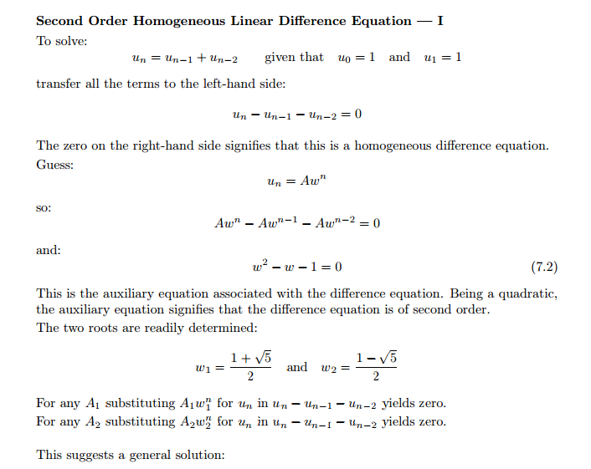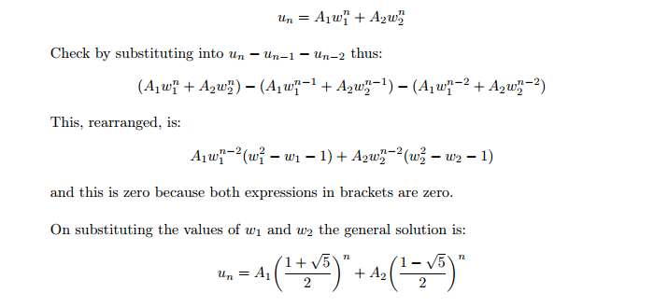

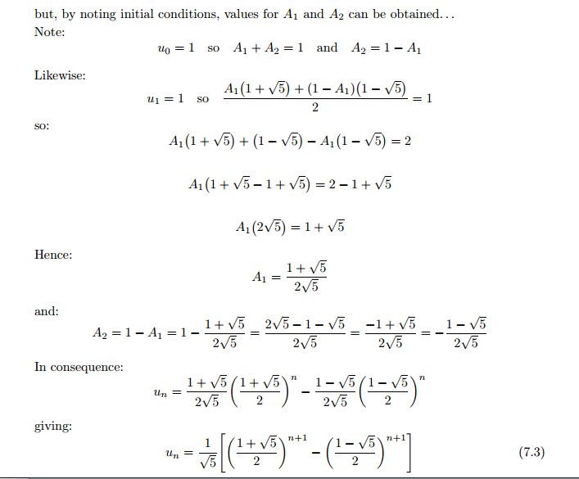

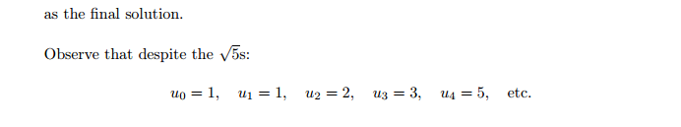

clc

clear all

symsnk1k2m

assume(n,'integer')

a = input('Enter the coefficient of y(n+2): ');

b = input('Enter the coefficient of y(n+1): ');

c = input('Enter the coefficient of y(n): ');

g = input('Enter the non-homogeneous part: ');

r = subs(solve(a*m^2+b*m+c,m));

ifimag(r)~=0

rho = sqrt(real(r(1))^2 + imag(r(1))^2);

theta = atan(abs(imag(r(1)))/real(r(1)));

y1 = (rho^n)*cos(n*theta);

y2 = (rho^n)*sin(n*theta);

elseif r(1)==r(2)

y1 = r(1)^n;

y2 = n*r(1)^n;

else

y1 = r(1)^n;

y2 = r(2)^n;

end

Co = det([y1, y2;subs(y1,n,n+1), subs(y2,n,n+1)]); %Casoratian of the solutions

y_c = k1*y1 + k2*y2;

disp('Complementary Solution is: ');

disp(y_c);

if(g ~= 0)

y11 = subs(y1,n,n+1);

y21 = subs(y2,n,n+1);

Co1 = subs(Co,n,n+1);

u1 = simplify(symsum(-g*y21/Co1,n))

u2 = simplify(symsum(g*y11/Co1,n))

y_p = simplify(u1*y1+u2*y2);

y = y_c + y_p;

else

y = y_c;

end

check = input('If the given problem has initial conditions then enter 1 else enter 0: ');

if (check == 1)

yval1 = input('Enter the initial condition at n = 0: ');

yval2 = input('Enter the initial condition at n = 1: ');

cond1 = strcat(char(subs(y,n,0)),'=',num2str(yval1));

cond2 = strcat(char(subs(y,n,1)),'=',num2str(yval2));

[k1,k2] = solve(cond1,cond2);

y = subs(y);

end

disp('Complete Solution is: ')

disp(collect(collect(y,y1),y2))

if(check ~= 0)

nrange = 0:10;

Y = subs(y,n,nrange);

stem(nrange,Y);

set(gca,'XTick',linspace(0,10,11))

xlabel('n');

ylabel('y(n)');

end

Engineering interpretations:

Z transform is a very useful concept in the field of computer science.It is used by almost all of computer programming languages like c ,c++,python,java,php etc.Its main use is to compute the running time for a given algorithm (computer program).Apart from computing the running time it is also used in designing for various purposes .